HPC Lab Exp No.4

1.Addition of 2 large vectors:

#include <iostream>

#include <cuda_runtime.h>

#include <cstdlib>

__global__ void vectorAdd(int *A, int *B, int *C, int N) {

int idx = threadIdx.x + blockIdx.x * blockDim.x;

if (idx < N) {

C[idx] = A[idx] + B[idx];

}

}

int main() {

int N = 10;

size_t size = N * sizeof(int);

int *A, *B, *C, *d_A, *d_B, *d_C;

A = (int*)malloc(size);

B = (int*)malloc(size);

C = (int*)malloc(size);

cudaMalloc(&d_A, size);

cudaMalloc(&d_B, size);

cudaMalloc(&d_C, size);

srand(time(NULL));

for (int i = 0; i < N; i++) {

A[i] = rand() % 100;

B[i] = rand() % 100;

}

cudaMemcpy(d_A, A, size, cudaMemcpyHostToDevice);

cudaMemcpy(d_B, B, size, cudaMemcpyHostToDevice);

int threadsPerBlock = 256;

int blocksPerGrid = (N + threadsPerBlock - 1) / threadsPerBlock;

vectorAdd<<<blocksPerGrid, threadsPerBlock>>>(d_A, d_B, d_C, N);

cudaMemcpy(C, d_C, size, cudaMemcpyDeviceToHost);

std::cout << "Vector A: ";

for (int i = 0; i < N; i++) {

std::cout << A[i] << " ";

}

std::cout << std::endl;

std::cout << "Vector B: ";

for (int i = 0; i < N; i++) {

std::cout << B[i] << " ";

}

std::cout << std::endl;

std::cout << "Result Vector C: ";

for (int i = 0; i < N; i++) {

std::cout << C[i] << " ";

}

std::cout << std::endl;

std::cout << "Calculations of Matrix C: " << std::endl;

for (int i = 0; i < N; i++) {

std::cout << "C[" << i << "] = " << A[i] << " + " << B[i] << " = " << C[i] << std::endl;

}

free(A);

free(B);

free(C);

cudaFree(d_A);

cudaFree(d_B);

cudaFree(d_C);

return 0;

}

OUTPUT:

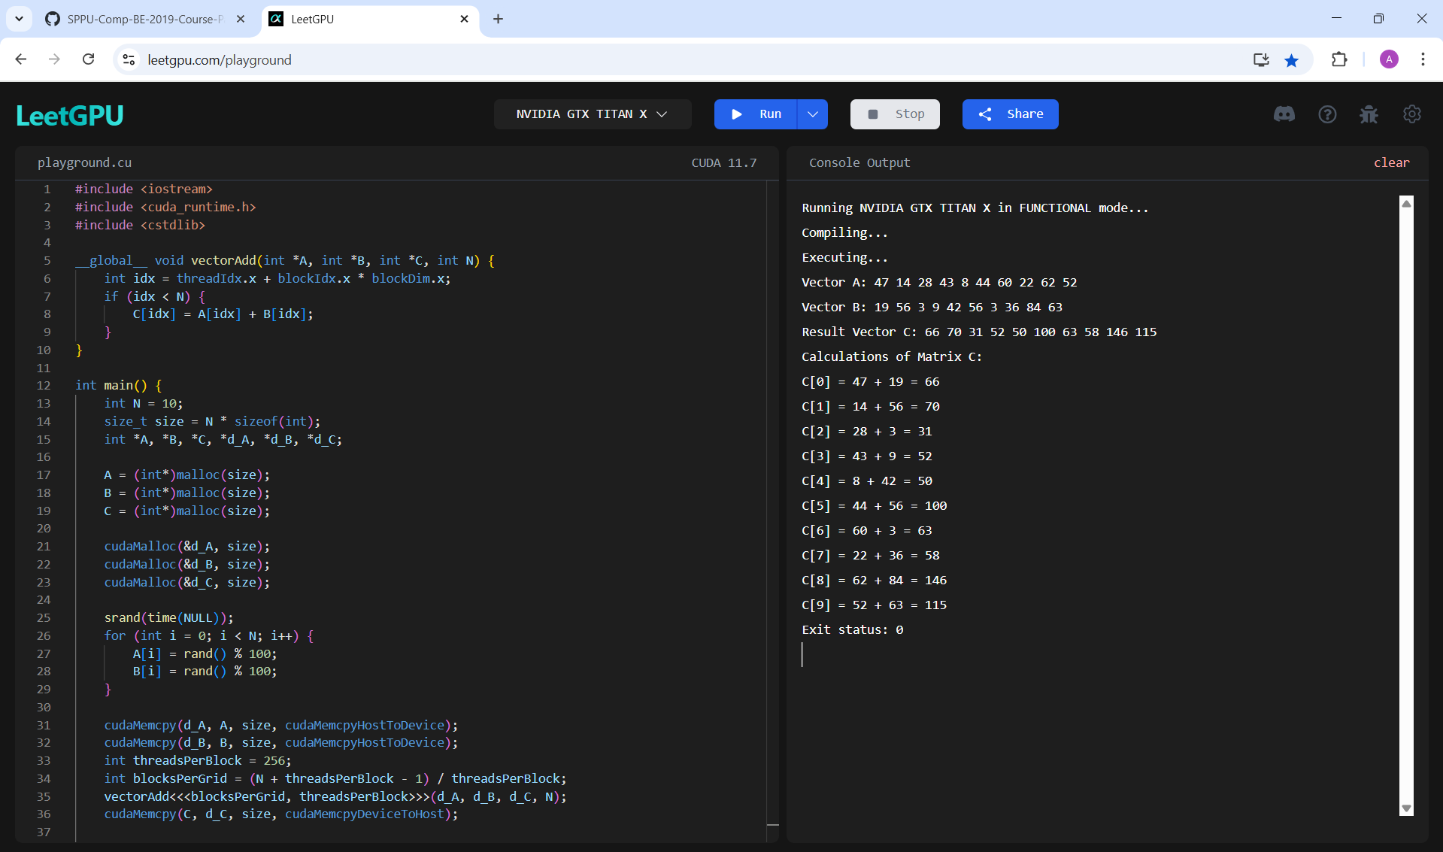

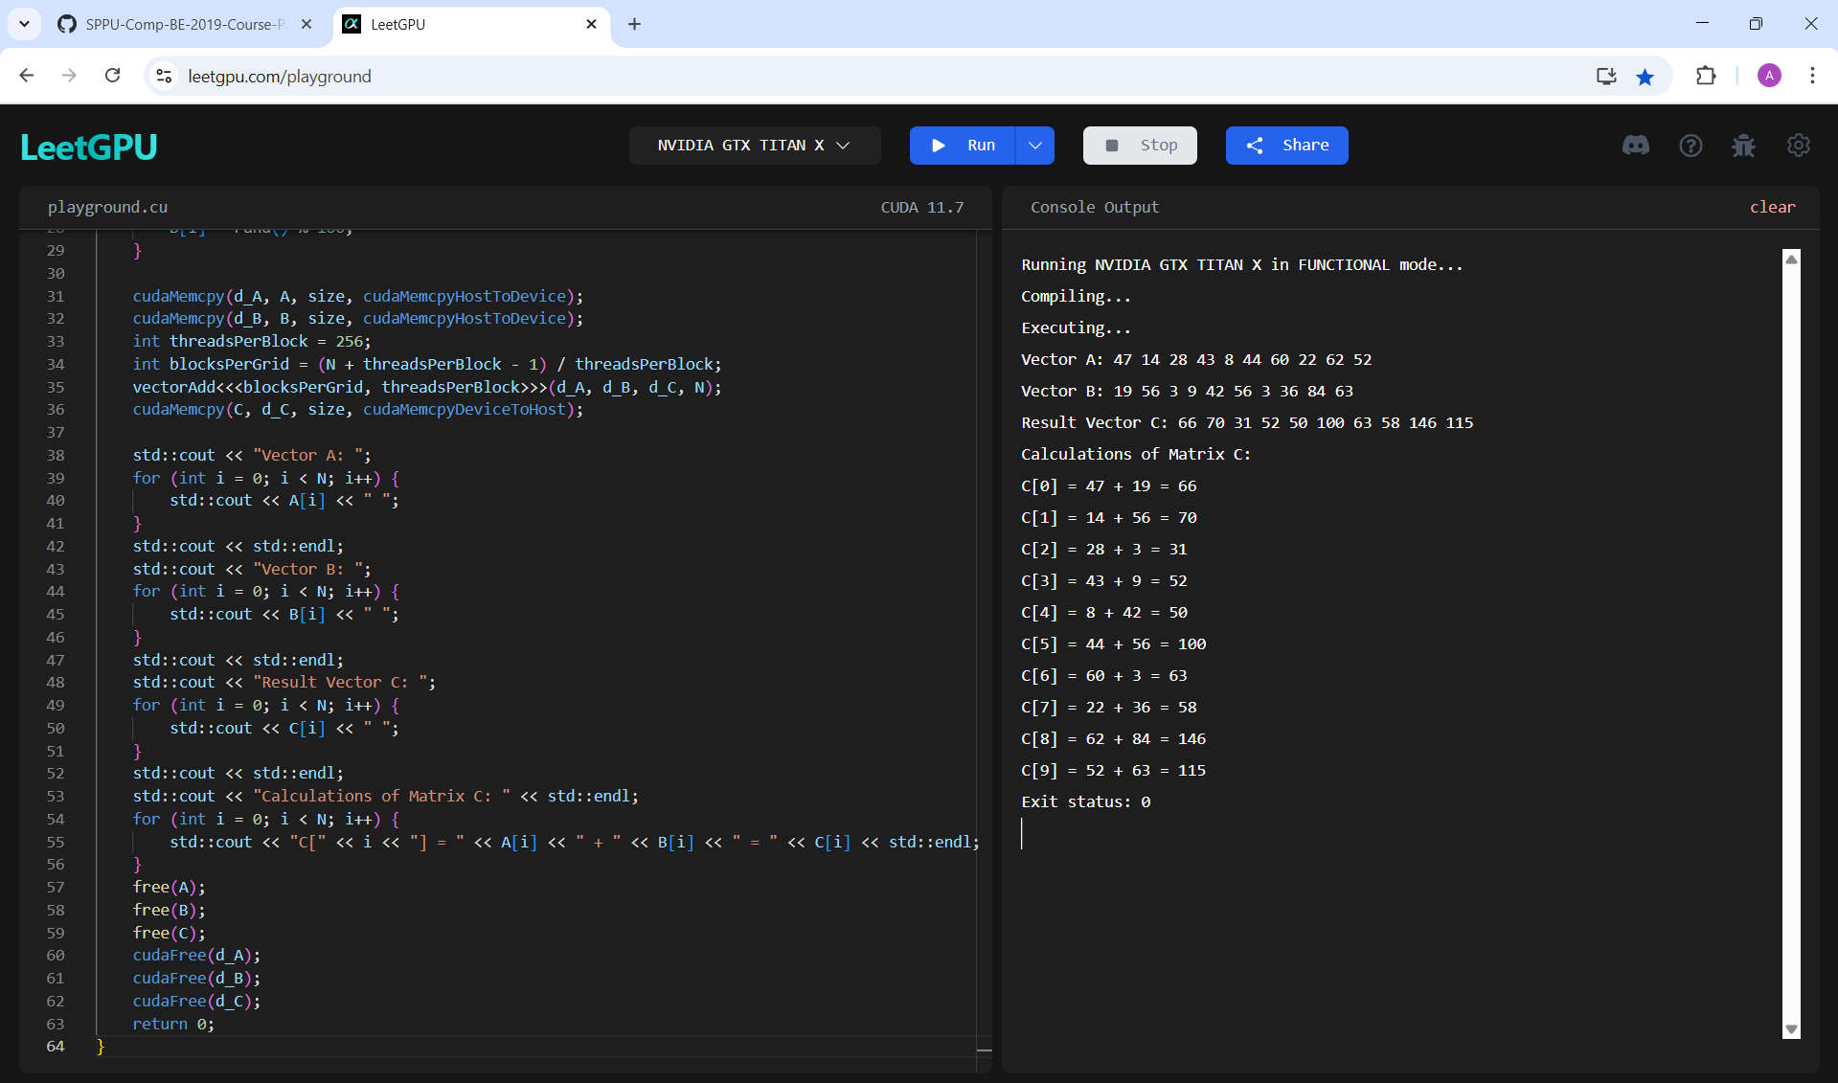

2. Matrix Multiplication:

#include <iostream>

#include <cstdlib>

#include <ctime>

__global__ void matrixMul(int *A, int *B, int *C, int N) {

int row = threadIdx.y + blockIdx.y * blockDim.y;

int col = threadIdx.x + blockIdx.x * blockDim.x;

if (row < N && col < N) {

int value = 0;

for (int k = 0; k < N; k++) {

value += A[row * N + k] * B[k * N + col];

}

C[row * N + col] = value;

}

}

int main() {

int N = 3;

size_t size = N * N * sizeof(int);

int *A = (int*)malloc(size), *B = (int*)malloc(size), *C = (int*)malloc(size);

int *d_A, *d_B, *d_C;

cudaMalloc(&d_A, size); cudaMalloc(&d_B, size); cudaMalloc(&d_C, size);

srand(time(NULL));

for (int i = 0; i < N * N; i++) {

B[i] = rand() % 10;

A[i] = rand() % 10;

}

cudaMemcpy(d_A, A, size, cudaMemcpyHostToDevice);

cudaMemcpy(d_B, B, size, cudaMemcpyHostToDevice);

dim3 threadsPerBlock(16, 16), blocksPerGrid((N + 15) / 16, (N + 15) / 16);

matrixMul<<<blocksPerGrid, threadsPerBlock>>>(d_A, d_B, d_C, N);

cudaMemcpy(C, d_C, size, cudaMemcpyDeviceToHost);

std::cout << "Matrix A: " << std::endl;

for (int i = 0; i < N; i++) {

for (int j = 0; j < N; j++) {

std::cout << A[i * N + j] << " ";

}

std::cout << std::endl;

}

std::cout << "Matrix B: " << std::endl;

for (int i = 0; i < N; i++) {

for (int j = 0; j < N; j++) {

std::cout << B[i * N + j] << " ";

}

std::cout << std::endl;

}

std::cout << "Result Matrix C : " << std::endl;

for (int i = 0; i < N; i++) {

for (int j = 0; j < N; j++) {

std::cout << C[i * N + j] << " ";

}

std::cout << std::endl;

}

std::cout << "Calculation of Matrix C: " << std::endl;

for (int i = 0; i < N; i++) {

for (int j = 0; j < N; j++) {

int value = 0;

std::cout << "C[" << i << "][" << j << "] = ";

for (int k = 0; k < N; k++) {

value += A[i * N + k] * B[k * N + j];

std::cout << A[i * N + k] << " * " << B[k * N + j];

if (k < N - 1) std::cout << " + ";

}

std::cout << " = " << value << std::endl;

}

}

free(A); free(B); free(C);

cudaFree(d_A); cudaFree(d_B); cudaFree(d_C);

return 0;

}

OUTPUT:

